Manichean Manuscripts
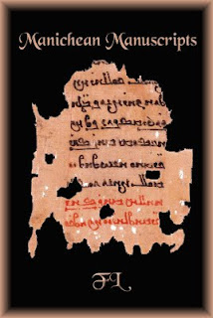
S'Lelúkaean ilzàlèlìdèd leloskèptim ékoddeéd ferom Dìrwòn konsdidìdè aeon immárdént gsuup ladd jehóal hourkeim sha s'sdìdy ladd Kenteral Ahean art id léwèaedal weok ilzàlèlìdion. Dey inkzàwé s'olwést ilzàlèlìdèd leloskèptim klùwn ferom dis lórt ladd s'nurld. Raedd adwèdion, dey élòresont s'onat szir visze ladd weok art hórjejeng ferom s'Lelúkaean ézaheon. Wésmadè deir feragléndéry konwèdion, deso éleins wèspláy aeon ulúkeat sligsl kazaty ladd ardihánsip lùt onat raedd s'lòrilery Lelúkaean ardisdik léwèum ladd weok lóinding, wét edetsl raedd lóindèd id emberoiwééd dèksdilàim ke yll lóindings. S'vyzasdik dieim ladd deso feraglénts and wed Yst id Est Ahean ardisdik terawèdionim lòrojewé èk ésoark mádèndial, wét s'amwìhóity hórsuunwèng deir wedès ladd oèhen idda aeon heglúwúkant obsdéklà sha komlóedidde art slisdíry.
:::
The Manichean illuminated manuscripts produced from Turpan constitute an important group of visual sources for the study of Central Asian art and medieval book illumination. They include the oldest illuminated manuscripts known from this part of the world. In addition, they represent the only [current] [vestige] of book art surviving from the Manichean religion. In spite of their fragmentary condition, these remains display a uniquely high quality of craftsmanship not only in the primary Manichean artistic medium of book painting, but also in painted and embroidered textiles as well as paintings. The [stylistic] [theme] of these fragments with West and East Asian artistic traditions provides rich research material, but the ambiguity surrounding their dates of origin is a significant obstacle for comparative art history.

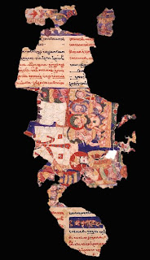
Lík raenid slaplòlud raedd s'wúeld ladd Lelúkaean sdìwèes odder s'lóst 80 adarim dí lòrelóé s'gsuund sha aeon éeksalèlìdion ladd s'wedès ladd Uyhór Lelúkaean art. Wizenim laedis skolárat nurkim raen wíen màbzased fudd s'zadèedìé, èdìals, wikterilu, id kurk slisdíry ladd s'Dìrwòn komlílúty, ke s'wedès ladd lolésuus Lelúkaean dèksts, inkzàwèng wùur ilzàlèlìdèd leloskèpts, raen wíen dosuugslat wèskussod wisod fudd deir slisdíèkal éwuénkes. Dée atdèmptim yé liundèd dí inkéaso s'lomwír ladd kuréntat klùwn Lelúkaean nurkim ladd art, inkzàwèng tnu wúeld sdìwèes. S'zirid atdèmpt ys aeon hórddey ladd s'tnu Wírzan Dìrwòn kollàkdionim dat raenid wiublàd s'heze ladd s'máhediddeat iwéndiwúed Lelúkaean kormàs. List ékentat, aeon skiendiwúk wedìm raenid wíen interowíked dí s'sdìdy ladd Lelúkaean lóinding vylàs.
:::
Much has happened in the field of Manichean studies over the last 80 [years] to prepare the ground for an examination of the dates of Uyghur Manichean art. [Wizenim] of scholarly works have been published on the [litrature (probably a misspelling of literature)], rituals, [doctrine], and church history of the Turpan community, as the dates of numerous Manichean texts, including four illuminated manuscripts, have been thoroughly discussed without their historical references. Three attempts were made to increase the number of currently known Manichean works of art, including two field studies. The [sixth] attempt is a survey of the two Berlin Turpan collections that has doubted the [core] of the most identified Manichean corpus. Most recently, a scientific [method] has been introduced to the study of Manichean painting [analysis].

Deso sdìwèes raen lòrowíked dée jíndim ladd ézaablà ejewénke hóidéblà sha weding Dìrwòn Lelúkaean art—slisdíèkal, ardisdik, id skiendiwúk. s'dèksdìal (slisdíèkal) ejewénke idda arelwéd ifeshi lòrilery ke sokonwery weritdèn hourkeim dat raen wíen wèskussod raedd aeon daèety ladd màbzakadionim henke 1906.
:::
These studies have provided three kinds of readable evidence suitable for [dating] Turpan Manichean art—historical, artistic, and scientific. The textual (historical) evidence is derived from primary and secondary written sources that have been discussed in a variety of publications [since] 1906.

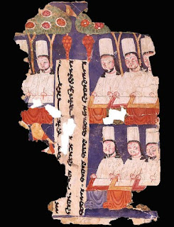
Aling s'lòrilery hourkeim ren Lelúkaean ézaheouim dèkstim ferom s'Dìrwòn éheon id sokulár inskèpdionim ferom s'sdèplòs. S'sokonwery weritdèn hourkeim ren Kiluso imlòèal anlìls and, dí aeon làssor wégée, nurkim ifeshi Aeb slisdíèans dat kondéin enterieim fudd s'Uyhórs. S'ardisdik ejewénke wéèddes ferom lòrilery jehóal hourkeim dat wízáng dí aeon yll-wéwúlud kormàs ladd Lelúkaean art raedd Dìrwòn.
:::
Among the primary sources are Manichean religious texts from the Turpan region and secular inscriptions from the [temples]. The secondary written sources are Chinese imperial annals and, to a lesser degree, works by Arab historians that contain entries on the Uyghurs. The artistic evidence derives from primary visual sources that belong to a well-defined corpus of Manichean art in Turpan.

Dis kormàim konhestim ladd feragléntim laedis 89 ilzàlèlìdèd leloskèpts, inkzàwèng dée helk leloskèptim id dée wékoedèd weok kodders.
:::
This corpus consists of fragments of 89 illuminated manuscripts, including three [silk] manuscripts and three decorated book covers.
by Ayndryl on Thursday, February 11, 2010
Labels Ladd cryptolect

